REPORT
ON THE APPROACH OF AGRO-ECOLOGY IN ITALY
by Osservatorio Europeo del Paesaggio
Salvatore BASILE, Domenico NICOLETTI, Angelo PALADINO
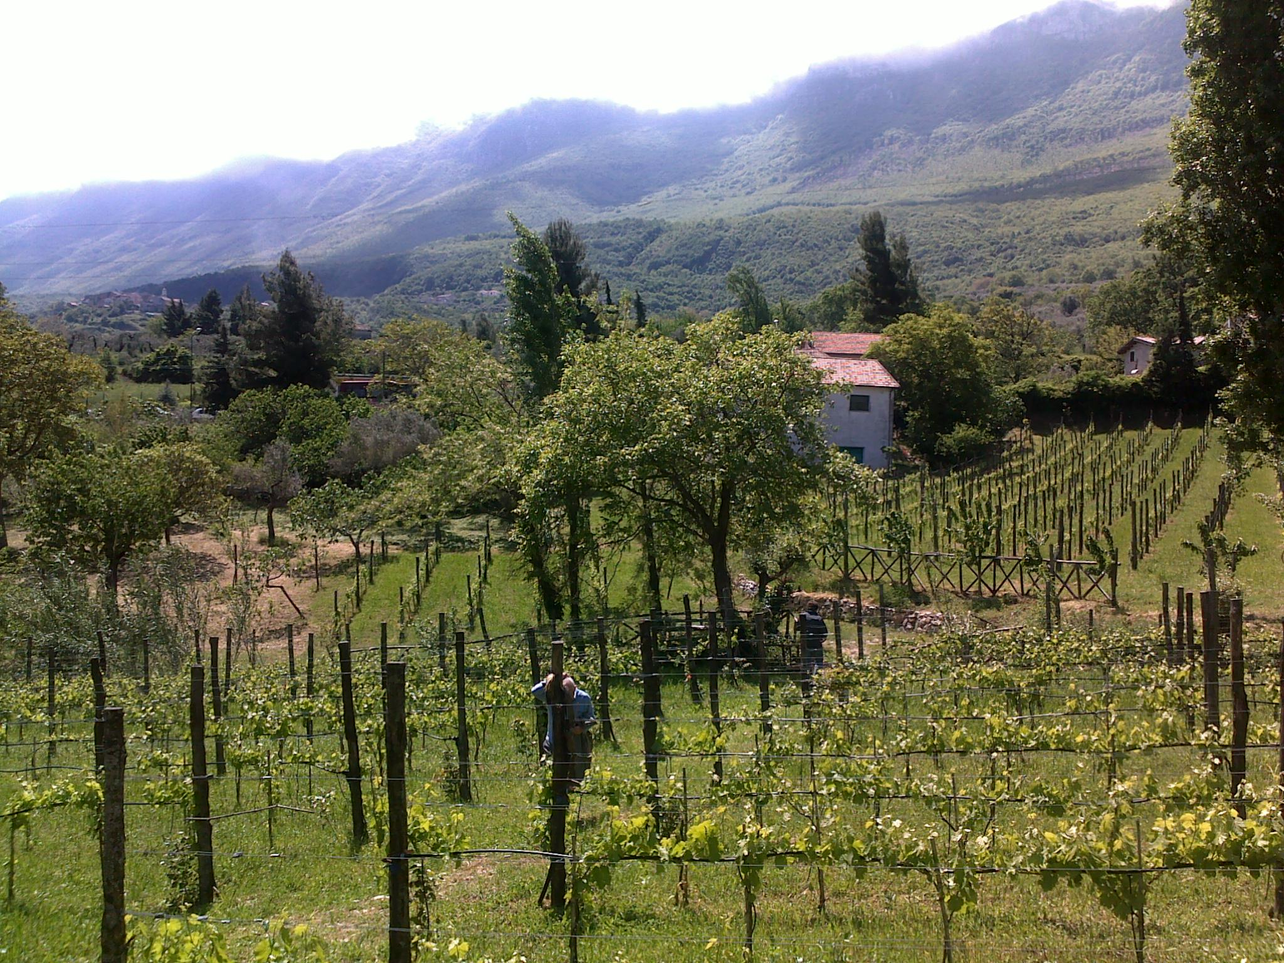

English version

Cover: Organic farm “Il sentiero del Riccio” – Bio-district Cilento – Sicignano degli Alburni (SA)

© 2016 Osservatorio Europeo del Paesaggio
Certosa di San Lorenzo
84034 Padula (SA)
www.osservatoriopaesaggio.eu

The aim of the project Erasmus plus “Euro-EducATES” is to develop and disseminate common and innovative European educational tools to help teachers and trainers in order to transmit the essential knowledge and skills for the agro-ecological transition.

The Italian partner of the project, the European Landscape Observatory, produced the Report on the status of the agro-ecological approach in Italy.

In the picture the authors of the Report: Salvatore BASILE, Domenico NICOLETTI, Angelo PALADINO.

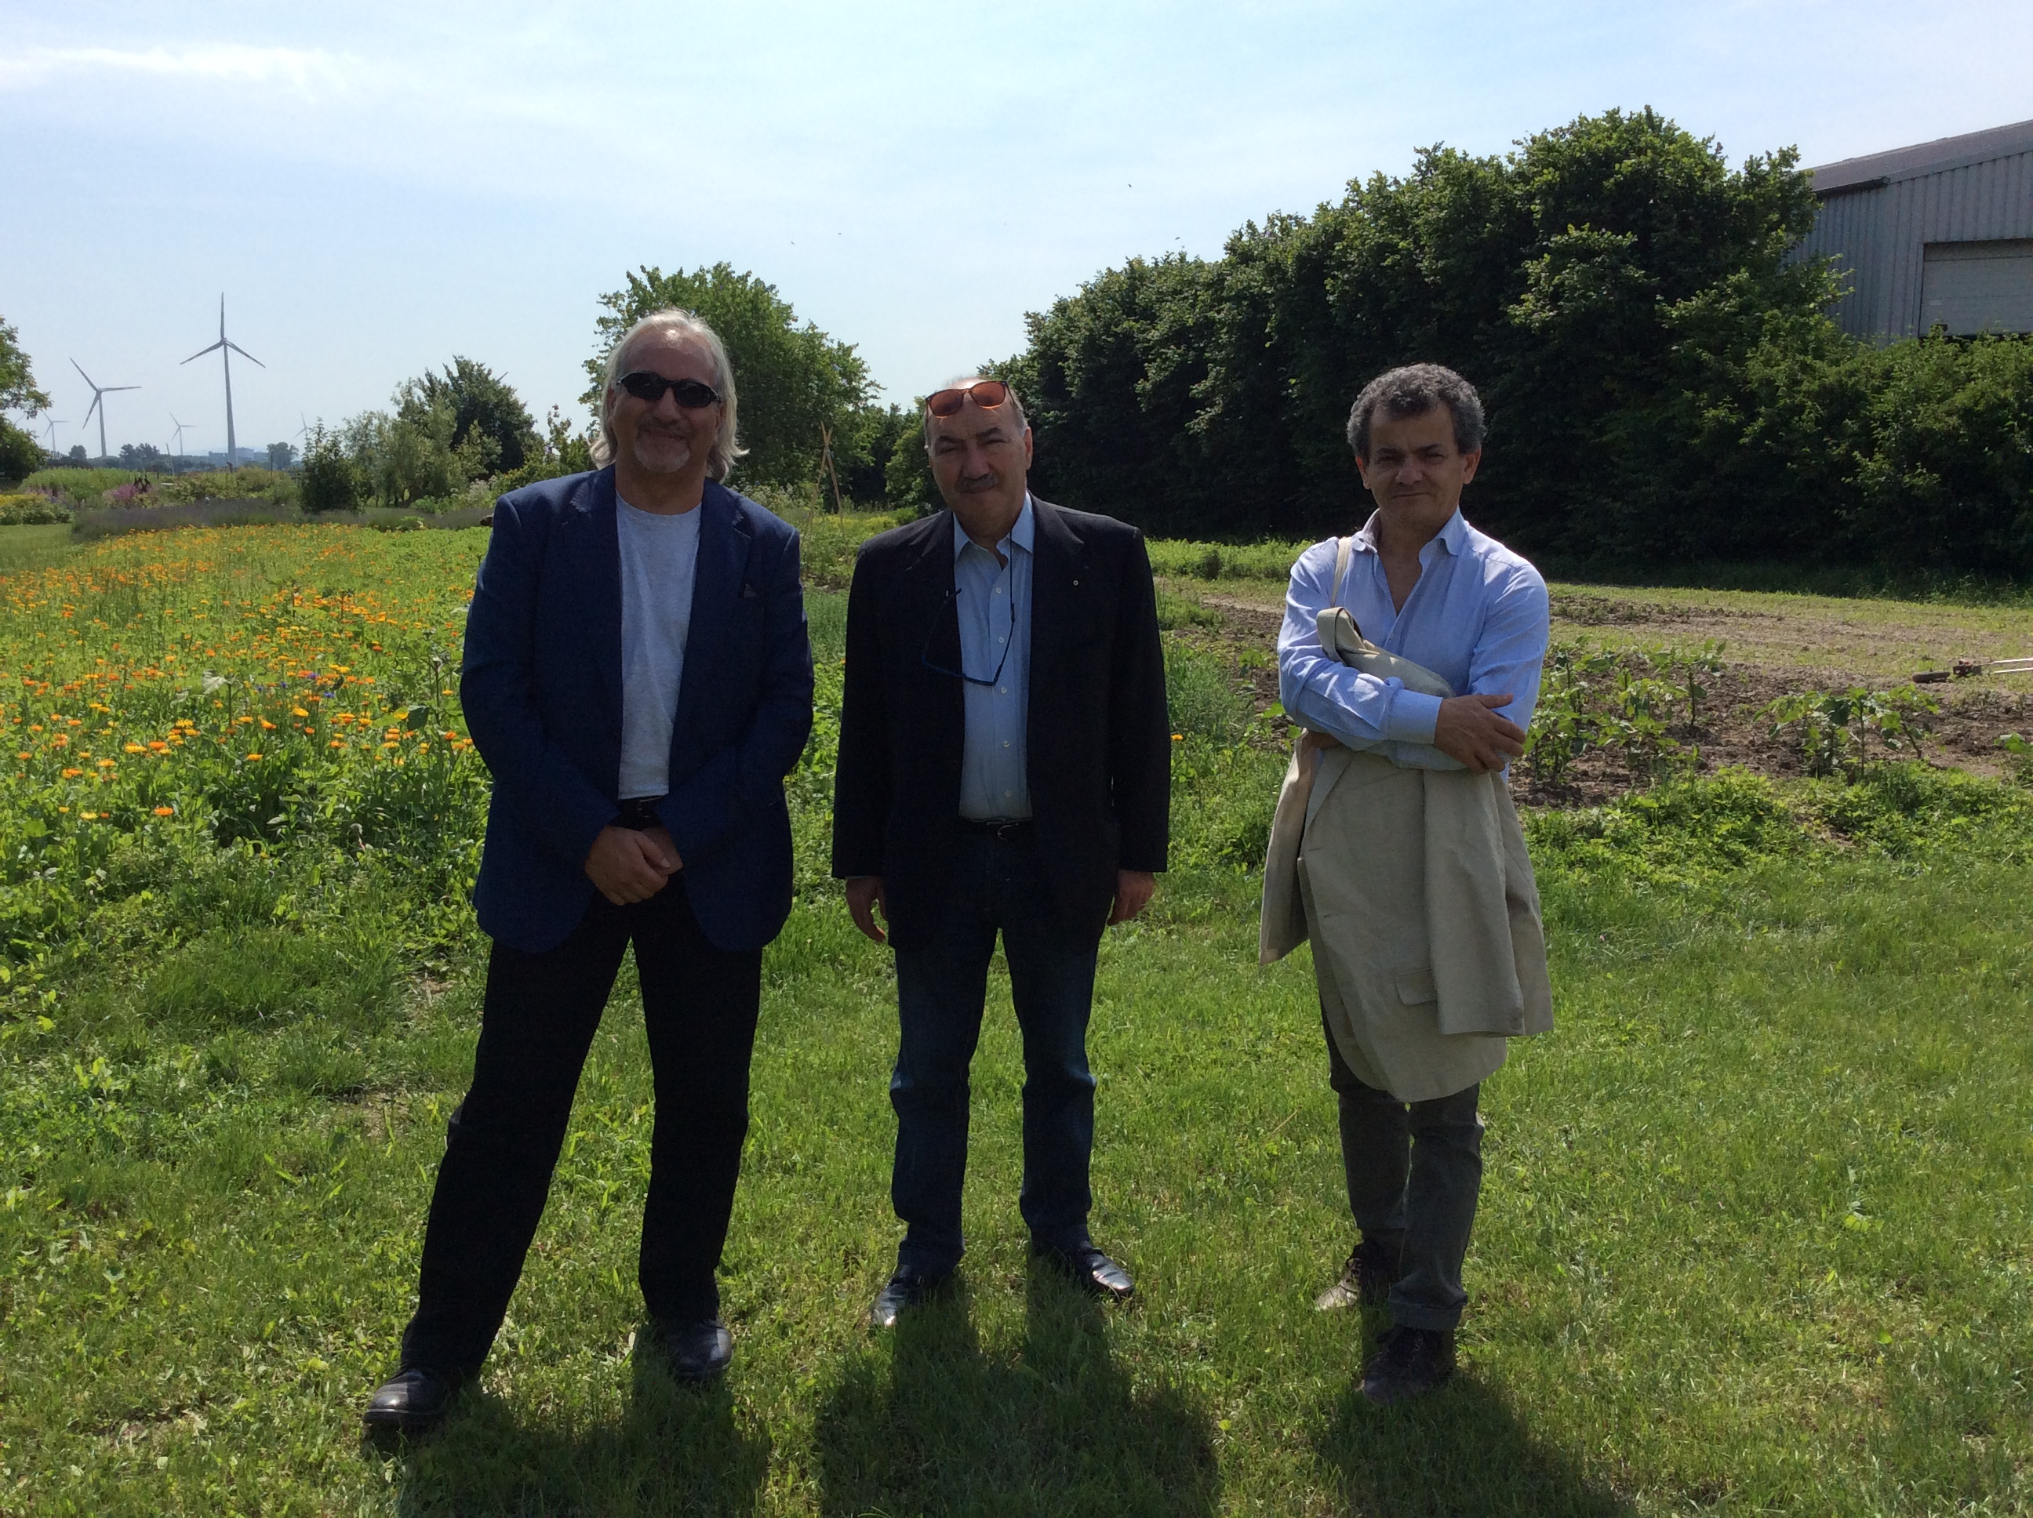

This project has been funded with support from the European Commission. This communication reflects the views only of the author, and the Commission cannot be held responsible for any use which may be made of the information contained therein.

Table of Contents
INTRODUCTION 5
DEFINITION OF AGROECOLOGY 6
PUBLIC POLICIES 14
RESEARCH 24
TRAINING / PEDAGOGY 27
CONCLUSIONS 29
BIBLIOGRAPHY 31

ACRONYMS AND DEFINITIONS

ΑCRONYMS | DEFINITION
Euro-EducATES | Acronym of the project “Teaching Agro-ecology in the transitory period and its consequences for the Agricultural Knowledge Systems”
AIAB Campania | Associazione Italiana per l’Agricoltura Biologica della Campania (Italian Association for Organic Farming – Campania)
BOKU | University of Natural Resources and Life Sciences, Wien
CEZ/BN | Zootechnic and animal science training center/National sheep center of Rambouillet
IFOAM | International Federation of Organic Agriculture Movements
IN.N.E.R. | International Network of Eco Regions
MIPAAF | Ministero Italiano per le Politiche Agricole, Agroalimentari e Forestali (Italian Ministry of Agriculture, Food and Forestry Policies)
MFA | Multifunctional Agriculture
OEP | Osservatorio Europeo del Paesaggio (European Landscape Observatory)
PAC | Politica Agricola Comunitaria (CAP – Common Agricultural Policy)
PEI | Partenariato Europeo per l’Innovazione (EIP – European Innovation Partnership)
PLZMMC | Lithuanian Centre for Programme LEADER and agricultural training methodology
POF | Piano per l’offerta formativa nella scuola (Plan for the educational offer in the school)
PSR | Programma di Sviluppo Rurale (RDP – Rural Development Programme)
SAU | Superficie Agricola Utilizzata (UAA - Utilized Agricultural Area)
SIB | Sistema Informativo italiano per il Biologico (Italian Information System for Organic Farming )
SINAB | Sistema di Informazione Nazionale sull’Agricoltura Biologica (Italian Information System on Organic Agriculture)
SOAAN | The Sustainable Organic Agriculture Action Network
UM | University of Maribor

INTRODUCTION

The Italian precursors of agro-ecology were the agronomists Pietro Cuppari, professor at Pisa University and Girolamo Azzi, professor at Perugia University; more recently, stands out the scientific activity of Fabio Caporali, professor at the Tuscia University of Viterbo, Paolo Bàrberi professor at University Sant’Anna of Pisa and Professor Salvatore Ceccarelli, author among others of important studies on the agro-ecology and alternative (participatory) methods of Plant Breeding.
With his studies, Pietro Cuppari was in 1862 the first to consider a farm as a “living body”, made up of interacting parts to be organized harmonically under physical, biological, technological and economical constraints.
Agro-ecology is considered today a transdisciplinary field of enquiry that is capable of changing our common vision of both agriculture and society (Caporali).
Organic farming, at present, is the main driver of agro-ecological research in Italy.
Agro-ecology in Italy is inherently connected to the development of organic farming, therefore this report provides an overview of this sector, with a special focus on the new territorial approach (bio-districts/Eco-Regions).
The Bio-districts experience, originated in the year 2004 by AIAB Campania in Cilento area (Province of Salerno, Italy), is today spreading across the country.
The Bio-districts (or Eco-regions) are in line with the Organic 3.0 model, more holistic and dynamic.
The Italian Ministry of Agriculture introduced the agro-ecological approach and the bio-districts experiences in the National Action Plan for organic farming, approved the 24th of March 2016.

DEFINITION OF AGROECOLOGY

In Italy two of the precursors of agro-ecology were the agronomists Pietro Cuppari (1816-1870), professor at Pisa University (famous for his studies on the farm as agroecosystem) and Girolamo Azzi (1885-1969), professor at Perugia University, the founder of the agrarian ecology. The pioneering work of Cuppari was later re-assessed and expanded by Alfonso Draghetti with a seminal book entitled Principles of physiology of a farm (1948). More recently, since the ‘80s, stands out the scientific activity of Fabio Caporali, professor at the Tuscia University of Viterbo; in 2015 he published the “History and development of agroecology and theory of agroecosystems”.
According to the most recent Italian studies, the Agro-ecology is the application of the ecological science and principles to agricultural systems. It involves various approaches and dimensions, such as environmental, economic, ethical and social aspects.
Agro-ecology is considered today a transdisciplinary field of enquiry that is capable of changing our common vision of both agriculture and society.
“Ecology studies the relationship between living organisms and the environment in which they develop. This necessarily entails reflection and debate about the conditions required for the life and survival of society, and honesty needed to question certain models of development, production and consumption”⁴.
“It cannot be emphasized enough how everything is interconnected. Time and space are not independent of one another, and not even atoms or subatomic particles can be considered in isolation. Just as the different aspects of the planet – physical, chemical and biological – are interrelated, so too living species are part of a network which we will never fully explore and understand. A good part of our genetic code is shared by many living beings. It follows that the fragmentation of knowledge and the isolation of bits of information can actually become a form of ignorance, unless they are integrated into a broader vision of reality”⁴.
“When we speak of the environment, what we really mean is a relationship existing between nature and the society which lives in it. Nature cannot be regarded as something separate from ourselves or as a mere setting in which we live. We are part of nature, included in it and thus in constant interaction with it”⁴.
It is now necessary to move towards an “Integral Ecology: environmental, economic and social”.
Agroecology in Italy is inherently connected to the development of organic farming, therefore this report provides an overview of this sector, with a special focus on the new territorial approach (Bio-districts/Eco-Regions).

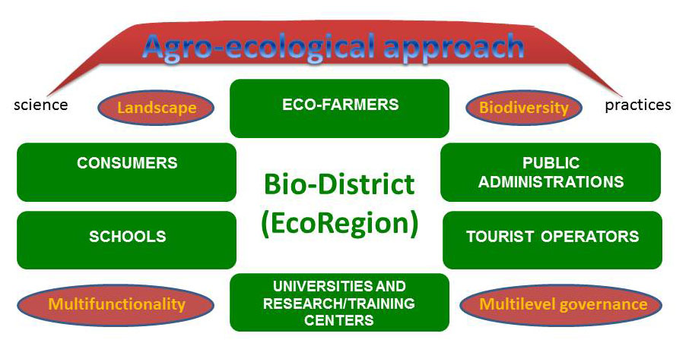
In a Bio-district the promotion of organic productions is inextricably linked with the promotion of the land and its special characteristics. So, it can be fully realized its economic, social and cultural potential.
The Bio-districts experience, originated in the year 2004 by AIAB Campania in Cilento area (Province of Salerno, Italy), is today spreading across the country. At present 15 Bio-districts are operating in 10 regions (Campania, Calabria, Latium, Marche, Tuscany, Liguria, Piedmont, Trentino Alto Adige, Lombardy, Sicily). In 2014 was established the International Network of Eco-Regions (Bio-districts), based in Rome.
The Bio-districts are in line with the Organic 3.0 model, more holistic and dynamic.
Bio-district is a territory of a sub-regional level with a no profit association amongst agriculture enterprises and agro-food farmers, citizens/consumers, even associated together as with the fair trade groups, local public administrations, national and regional parks, protected natural areas, commercial, touristic and cultural enterprises, social cultural and environmental associations. They act according the principles and methods of the organic production and consumption and agro-ecology.
Each Bio-district is marked by lifestyle, nutrition, human relations, nature. It results that agricultural productions are more valuable and typically characterized, hence more appreciated by the market.
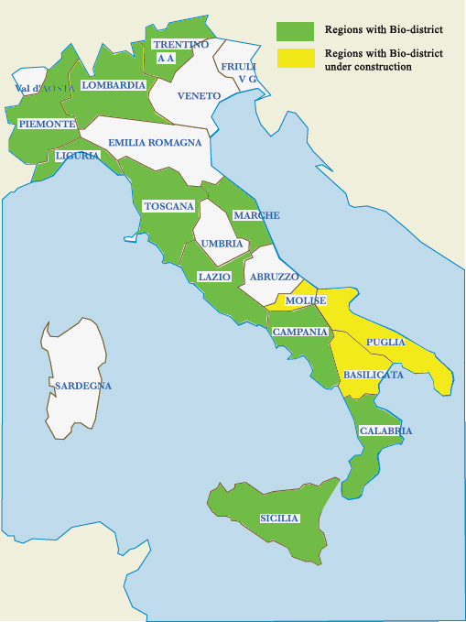
The productions resulting from the link between territorial vocations and production techniques are often enhanced by setting in production areas the stages of processing the agricultural product.
Hence the food product in these areas also becomes cultural heritage and a local identity mark: local economic and social actors become more responsible in the management of natural and environmental resources, which are common to several sectors (agriculture, tourism, commerce, etc.). This awareness has made the mobilisation and the protection of local resources more easy, most of all those related to agricultural systems and to agro-food industry.
Bio-districts in Italy
(Source IN.N.E.R.)

An integrated approach of sustainable development is adopted by a Bio-district. The different actors are involved for shared purposes: the improvement of the life quality, the employment of local population and the reduction of population’s decrease in rural areas, the employment increase of young people and women, and of the quality of agro-food productions and of local livestock premises.
Also to ensure the consumers safety, a traceable and healthy food, the increasing and seasonal regulation of tourist flows, through a multiple eco-tourism and local culture supply, biodiversity protection, enhance landscape and natural resources.

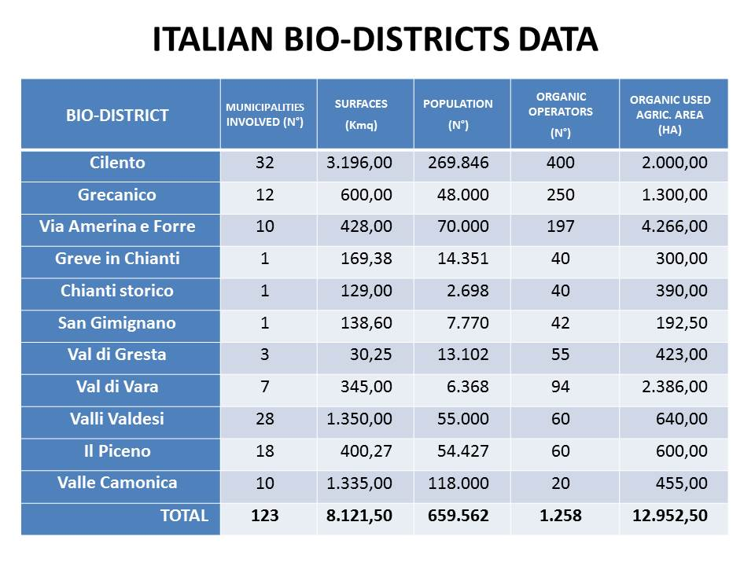
Data not available for the recent bio-districts of “Valle dei Laghi”, “Montalbano”, “Eolie”, “Simeto”, “Baticòs”.
(Source IN.N.E.R.)

The Bio-districts are therefore a real answer to the present trend of economic development causing massive phenomenon of abandonment of rural areas and the increasing urbanization of people in search of better condition of life and a higher income. The process affects both the most industrialized countries and developing countries, causing the degradation and the progressive impoverishment of territory resources, the loss of biodiversity and of the cultures and traditional knowledge.
The practices of Bio-districts are characterized by the agricultural and agro-food enterprise multifunction: a set of activities increasing its entrepreneurial added value as the renewable energy production (solar and bio-mass), the teaching-farms, the agro-schools for children, leisure activities as gardening care, kitchen courses in countryside, social agriculture for disabled people, imprisoned and drug addicts, direct and farmer markets, the maintenance of parks, gardens and the landscape preservation.
The multifunctional agriculture demonstrates that agro-farmers, in addition to ensure food production, increasingly important in the future, patrol and protect the territory, the biodiversity, the hydro geological balance, the landscape, natural resources, first of all water and land, local culture and traditions. It is an overall approach to the farm management: the agro-food production, that combines best environmental practices, a high level of biodiversity, preservation of natural resources and the application of high level animal welfare standards, as well as production methods following the responsive preferences of a growing part of consumers for products obtained from natural substances and processes.
The development processes in the Bio-districts’ territories focus therefore on these specific features, latent factors of development and topics of great significance, also linked to the considerable potential of the hidden resources existing in these areas.
In this way it is possible to make enjoyable and attractive the territories, acting on a whole of factors and trying to improve local agro-food productions and other economic sectors, to improve the transports, the use of renewable energies, enhancing cultures and local know-how, to invest in education at all levels, offering health services of good quality for all, circulating information, giving everybody access to the new Information and Communication Technologies and, most of all, promoting a long lasting and pro-active dialogue between institutions, associations and private sector.
This last issue is perhaps the most significant: agriculture and food production made through the social dialogue, direct commercialisation, by giving concrete answers to responsive consumers, can create growth and new employment, at the same time enriching the community. This practice of economy of development joints together sustainability, ethic labour and social cohesion.
The constitution of the IN.N.E.R. association intents answer to a double need of the Bio-districts: from one side strengthening the practices in place through a coordination strategy for development and continuous innovation, with a common line of action and exchange of information and experiences; on the other side sustaining the practices through a supporting political capacity at local, national and international level.
Operationally these goals also meet the challenges of the Bio-districts for the years to come:
- To increase the quality of organic production through further use of research and innovation, by the building of networks with IFOAM (International Federation of Organic Agriculture Movement) and the development of products, processes, practices and innovative technologies together with the protection of ecosystems and landscape: innovative methods for the management of pests, diseases and weeds; ecological plant protection; reduction of energy consumption of the greenhouses; improvement of soil fertility; more efficient use of energy; coexistence of organic farming and non-biological ingredients; and techniques for the processing of organic food by creating a virtuous circle of dissemination and exchange of information, knowledge and experiences.
- To improve and strengthen the multilevel governance policies, open and actively participated by the citizens; facilitate social dialog on reproduction and rationalization of the natural resources used (water footprint and biodiversity), pollution reduction (carbon footprint) and animal welfare.
- To involve all territorial actors and adopt the measurements of the undertaken processes which enable, in fact, a greater food security, increase the consumer’s confidence, allow an easier access for the small workers to the organic system, in an ambitious and rigorous context of rules for the certification of products. Furthermore it is worth to adopt the electronic certification to improve the territorial traceability of products.
- Finally, to promote and implement actions of international cooperation for the spread of the Bio-districts network, to help solving the serious imbalances of the current development that, together with some advantages, also produce poverty, exclusion, conflicts, violence and a serious decay of the environment that threaten the future of all. This line of activities is complementary to and integrate multilateral agreements amongst countries to enhance food security and the high quality of organic products.
The IN.N.E.R. network works through 4 interlinked thematic groups with the participation of the representatives of each adherent Bio-district:
Eco-tourism, to enhance and improve the quality of the Bio-district touristic offer with an innovative integration among natural and cultural resources, the artistic and architectural heritage and wide choice of hospitality, the improvement of environment and landscape, the promotion of culture, traditions and local knowledge, and of national and international markets.
Agro-food systems, to improve the connection of the typical productions of excellence from the Bio-districts with the extra-local and foreign markets and with consumers in national and foreign urban areas, through new channels and commercial services, making the public administrations sensitive to their green procurements; to increase the responsibility of the local economic and social actors in exploiting and preserving natural and environmental resources, reinforcing the integration between primary production, transformation and marketing methods, in order to improve the distribution of its added value in support of the agro-farms.
Energy to support the creation and to secure local chains of renewable sources by the monitoring of technological trends of energy systems and by facilitating connections with the institutions and national expertise centres. Energy saving and the production of renewable sources are encouraged, as well as the sustainable exploitation of biomass, favouring investments dedicated to energy conversion; the closure of the production and consumption cycles, and the creation of business systems for the treatment and energy production, derived from the use of solid and liquid animal waste, are also fostered.
Social inclusion, in order to deal with the issue of agriculture and social inclusion of disabled people, imprisoned, drug addicts, immigrants and at the same time the residents’ quality of life, in order to facilitate integration into the local community of disadvantaged groups and experiment new forms of welfare.
As highlighted before the Bio-districts are in line with the Organic 3.0 model, more holistic and dynamic.
Organic 1.0: yesterday – the pioneers,
Organic 2.0: today – business and regulations,
Organic 3.0: future – feeding the world sustainably - shift of conventional agriculture in the direction of organic agriculture and agro-ecology. From exclusion to inclusion, encouraging aggregation and relations with the other actors of the territories (as in the case of Bio-districts/Eco-regions).
Conventional can learn from organic!

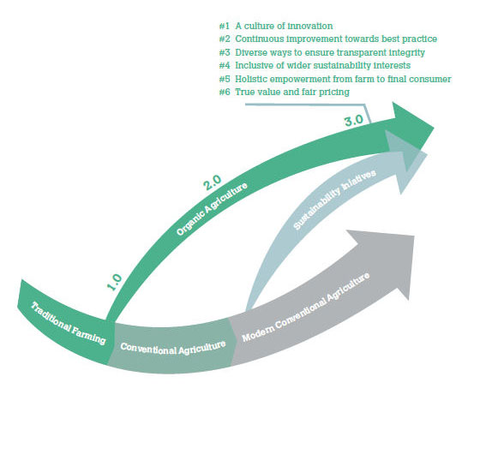
Visualization of the five dimensions and 20 criteria from the ‘Best Practice Guideline for Agriculture and Value Chains’ – IFOAM-Organics International.
Sustainable Food &
Farming Systems
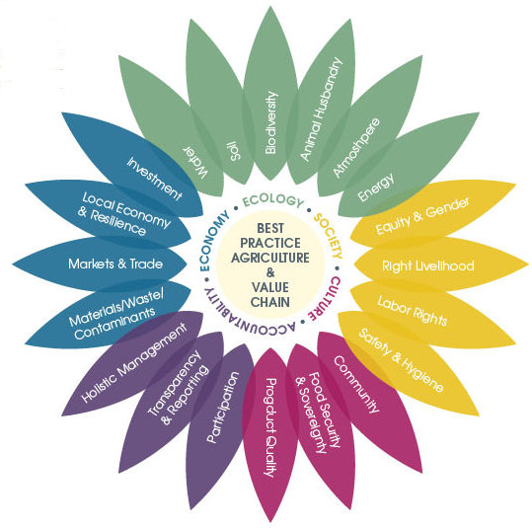
“Organic 1.0 was started by our numerous pioneers, who observed the problems with the direction that agriculture was taking at the end of the 19th century and the beginning of the 20th century and saw the need for a radical change.
Organic 2.0 started in the 1970s when the writings and agricultural systems developed by our pioneers were codified into standards and then later into regulatory systems.
Organic 3.0 is the third phase of the organic movement – the next paradigm. Organic 3.0 is about bringing organic out of a niche into the mainstream and positioning organic systems as part of the multiple solutions needed to solve the tremendous challenges faced by our planet and our species. It is about developing the new collective vision for the organic sector and about actively engaging with major global issues”.
(André Leu, President IFOAM Organics International, Urs Niggli, Chair SOAAN, 2015).

PUBLIC POLICIES
In Italy there isn’t a national programme of Agro-ecology, but the organic sector shows concrete agro-ecological solutions for agriculture and food systems. The current discussion is on the CAP & organic legal framework aimed at improving knowledge of rural actors about support offered under the new RDPs (Rural Development Programmes 2014-2020) for the development of organic farming as well as the agro-ecological approach.
In Italy there are 21 RDPs approved by EU, for a total amount of 1.689 millions of euro of public support for the organic farming sector, in transition from Organic 2.0 to Organic 3.0.
After the Universal Exhibition "EXPO 2015 Milan", dedicated to the theme "Feeding the Planet," Italy developed interesting legislative initiatives and experiments about a cultural advancement in the field of agro-ecology, also called for by civil society and by peasant movements that gave rise to the parallel forum called "Expo of Peoples", attended by 180 delegates from 54 countries representing 14 international networks.
The Forum ended with the "Food Sovereignty and Agro-ecology document" aimed at healing the sick food systems and presenting to the world the 10 big change strategies adopted and applied by the global networks. These include measures to promote agro-ecology and refuse its co-option by the industrial food system. Understood as a way of life.
“Agroecology is not a mere set of technologies or production practices, but rather an inclusive, holistic system of food production and processing through direct, fair and short distribution chains and self-governance. Its practices are based on ecological principles, and drastically reduce dependence on external inputs. Our strategies to promote agroecology include the promotion of appropriate health and sanitation regulations, horizontal and inter-generational exchanges of knowledge, and ensuring recognition of agroecology as a primary solution to climate change. We will fight corporate and institutional attempts to grab agroecology as a means of promoting GMOs and other fake solutions to climate change”.
In continuation of this action, it was formed in Italy the Expo Committee of Peoples pledged to disclose the contents of the document on the Italian territory (Grand Tour of Expo of Peoples) and to use the document as an evaluation tool of the Italian and European policies that deal with the right to food and the transition to more just and sustainable food and agricultural systems post 2015.
Among these activities, the Campaign for the Peasant Agriculture, with the dual purpose of:
(1) inform the public and compare experts about what are the laws and practices that prevent or promote peasant farming in Italy;
(2) make proposals about new practices, new laws and possible convergences that give them the space and dignity they deserve.
Among the recent Italian measures that go into agro-ecological direction, we report below the most significant.
Law no. 221 of 28 December 2015 laying down provisions relating to the environment, promoting green economy measures and the containment of excessive use of natural resources .
The law contains measures for the protection of nature and sustainable development, environmental assessments, energy, green procurement, waste management and reclamation, soil conservation and water resources. Article 67 sets up the Committee for Natural Capital, at the Ministry of Environment and Protection of Land and Sea, and regulates its functions and composition, in order to ensure the achievement of social, economic and environmental objectives consistent with the annual financial programming and the state budget. Article 70 delegates the Government the introduction of remuneration schemes of ecosystem and environmental services (PSEA), establishing the principles and criteria. With Article 72 comes the "National Strategy of Green Community", rural and mountain communities that consecrete to sustainability.
Among the pillars of the actions that these communities could undertake: integrated and certified management of agro-forestry, biodiversity management and certification of the wood industry; certified integrated management of water resources; production of energy from local renewable sources; development of sustainable tourism, capable of enhancing local production; construction and sustainable management; Energy efficiency and intelligent integration of the systems and networks; Sustainable development of productive activities; integration of mobility services.
It is also set up a new voluntary mark "Green Made in Italy" to indicate and communicate the environmental footprint of products. Those who buy will give priority to the "kilometer zero" certificate and to sustainable agricultural and industrial productions. Regulatory changes reinforced by another important measure called "Connected Agricultural" that opens up new scenarios of innovation and growth in the agricultural sector with particular regard to future generations and to the entry of young people in agriculture. It also established the Information System for the Organic (SIB).
Law no. 194 of 1st December 2015 containing provisions for the protection and enhancement of biodiversity in the interest of food and agriculture.
Also remember that in 2010 Italy adopted a "National Biodiversity Strategy", through which it aims to integrate the needs of biodiversity with the development and implementation of national sectoral policies and to define the vision for its preservation until 2020.
We also want to signal an interesting law proposal presented on March 5, 2015 on "Rules for the protection of the Earth, the recovery and development of abandoned farmlands and the support of farmers' agricultural activities". This is expressly referred to the great challenge of EXPO 2015 Milan as an opportunity to share with the people of the whole world experiences, projects and strategies for healthy food, safe, sustainable and sufficient for everyone. In addition, it is an opportunity not to be missed to build legislative routes that can sustain and improve our relationship with the earth and then with agriculture, spreading new awareness and sensitivity around heritage and values. For this reason the bill is divided into two parts. The first chapter brings together some of the rules designed to improve the management of land, considered common good, through the development of forms, including organizational, such as social promotion associations and interest groups, to improve and to socialize the access to the products of land and food security.
Chapter II, within the broader framework of the protection of the Earth, provides for the recognition and special support to the peasant farming. The peasant agriculture, which is one of the most significant expressions of family farming, when the latter is related to small size companies, is an ancient form of cultivation of fields and animal husbandry, which threatened to disappear due to industrial and intensive agricultural competition. But today peasant agriculture is gaining new attention on those who would return to the land and on those more attentive consumers of quality food. Moreover, either when you set it up as a main activity or when you set it up as supplementary activity, it represents an important resource in terms of self-employment and self-sustenance. The peasant agriculture was saved where it was able to maintain production and niche transformations, linked to local traditions, or, in the case of conversion of companies, in case of organic and biodynamic production. There is still an agriculture sized on rural work and family economy, oriented towards self and direct sales; an agriculture of low or no environmental impact, based on a lifestyle choice linked to welfare values, ecology and solidarity. This agriculture, which is likely to be invisible to the big numbers of the economy, is essential to keep the land fertile and cared for, especially in the hilly areas, in the mountainous and economically disadvantaged and marginal areas. It is an agriculture that in many cases keeps populated rural areas that would otherwise be abandoned, preserves the natural richness of landscapes, biodiversity of plants and animals and keeps alive ancient knowledge, techniques and local productions.
The peasant agriculture, as a phenomenon that constantly evolving, has accompanied human existence since ancient times, can not only be considered an economic activity, but a real complex and integrated life dimension. It interacts with ecosystems, the management of the territories, the expression of socio-cultural realities, whose values ​​and side effects are from an economic point of view, social and cultural development at least as significant as its strictly productive aspect.
The possibility of having an income or to supplement your own small income in this era of economic and employment crisis can be an important contribution to the budget of families, women, youth, the unemployed, pensioners, either in non-monetary terms with direct production of useful goods, or in monetary terms with the direct sale of products.
The peasant agriculture can well integrate with other non-agricultural sources of income helping to bring value and make more desirable the part time jobs available and multiplying, thus, the total number of available jobs.
The peasant agriculture, moreover, with its active and widespread presence is a decisive element of defence and protection of the territories, with virtuous and irreplaceable effects on the quality of the landscape, which in turn has repercussions on tourism, maintenance the hydrogeological balance, biodiversity, fertile layer of soil conservation, contrasting runoff and erosion; it also has effects on the preservation and evolution of Italian food and typical food, as a cultural and educational element useful also to environmental education and food of young people, and as the ideal environment for the social development of agriculture. The multifaceted character, manifold, multifunctional and complex peasant agriculture is not adequately recognized by the regulations that capture, in the best cases, only certain partial aspects isolating them from the richness and complexity that characterizes it.
In short, an innovative and inclusive vision of the Agro-ecology which integrates with the landscape and the identity of the territories. Such a vision, for example, is expressed in its state of excellence, in the territory of Cilento and it’s recognized by UNESCO as a model and lifestyle (Mediterranean Diet) Intangible Cultural Heritage of Humanity.
The general legislative framework is then completed at a regional level, as in the case of the Campania Region, with the Law approving the Regional Territorial Plan (PTR) with attached "Guidelines for the Landscape," which give concreteness to a new model of agro-ecological approach in a vision of "perceived landscape, lived and therefore also analysed and understood in many respects". In other words the PTR shows the landscape in a number of "dimensions", each of which can have greater or lesser importance depending on the characters, problems and trends of specific local situations. Historically, this essential polysemy and multidimensionality of the landscape explains the variety of looks, approaches and theoretical interpretations - geographical, historical, ecological, aesthetic, anthropological, etc. - developed in various scientific fields. But, in spite of the recurrent attempts by the different schools of thought, to "steal" the notion of landscape proposing "exclusive" interpretations, it is only by the interaction of several readings, from the intersection of knowledge and visions that the complex meaning and holistic understanding of the landscape is born. It is therefore considered appropriate that the entire path for the construction of the landscape plan should reflect the same multi-dimensionality of agro-ecology.
In general, the dimensions to be taken into account for the Campania Region should be at least four:
• the natural agro-ecological dimension (including the aspects agricultural, ecological, geomorphological, climatic, etc.);
• the economic-functional dimension (including the agricultural and forestry aspects, the economy of rural areas, economic use of natural resources, mobility and transport, etc.);
• the historical and cultural background (including the historical and archaeological aspects of the cultural heritage also intangible aspects, aspects of planning, settlement and infrastructure, etc.);
• the semiotic-anthropological dimension (including the aspects anthropological, sociological, semiological, aesthetic, perceptive, etc ..).
"A clearly open vision, to be defined on the basis of local specificities. It is only meant to remind the inevitably relational and complex nature of the landscape and the need to promote a cross- knowledge, able to support a basically "integrated management", which crosses the different incidents adopted on the territory.
The different aspects or different dimensions referred to above, in fact, have different weight and importance at different scales. This transcalarity obviously does not only concern the processes of knowledge but also the adjustment of the transformation processes, which are expressed by different evolutionary dynamics, while requiring a total of coherent and integrated policies.
The process of landscape planning cannot ignore the complexity of relationships - which will enrich and articulate the inter-institutional cooperation in the vertical direction - while respecting the ownership attributed to the Region by the Code of cultural heritage and landscape".
The Italian Ministry of Agriculture introduced the agro-ecological approach in the National Action Plan for organic farming, approved the 24th of March 2016.
The Plan includes a set of 10 actions, oriented in the direction of the transition from Organic 2.0 to Organic 3.0.
ACTION 1 - ORGANIC IN RURAL DEVELOPMENT PLANS – Development of a coordination among the different Italian Regions to bring into alignment the application rules of the Rural Development support measures for organic farming. A particular attention is given to promoting a specific agro-ecological approach.
ACTION 2 - SUPPLY CHAIN POLICY - Encouraging the aggregation of producers and stable relations with the other players of the sector, including processors, distributors and traders, through the implementation of specific association forms.
ACTION 3 - ORGANIC “MADE IN ITALY” AND INSTITUTIONAL COMMUNICATION - Introduction of a logo for the Italian organic products and promotion of international information campaigns also through the web.
ACTION 4 - ORGANIC AND GREEN PUBLIC PROCUREMENT - Encouraging the use of organic products in hospital catering and in school canteens, applying organic agriculture methods also in the management of public green areas.
ACTION 5 - SIMPLIFICATION OF THE ORGANIC LEGISLATION - A simplification of the rules governing the sector, involving regional administrations, also following the EU legislation updating.
ACTION 6 - EDUCATION, INFORMATION AND TRANSPARENCY - Organization of organic farming training courses at university level and of training courses for high school teachers. Strengthening of SINAB (the National Information System on Organic Farming) services to improve the availability of information on the sector.
ACTION 7 – “PAPER LESS” ORGANIC - COMPUTERISATION – Development of SIB - the Italian Organic Computerised System to facilitate the connection with other databases useful for the sector, with the aim of simplifying the operators’ procedures.
ACTION 8 - REVIEW OF CONTROL RULES – The aim is to Improve the effectiveness of the Italian control and certification system, as a guarantee for organic operators and consumers.
ACTION 9 - CONTROL ON IMPORTS – Improvement of control activities on products imported from third countries also through a deeper involvement of Customs and with the use of advanced IT tools so to facilitate the rapid exchange of information at all levels.
ACTION 10 - PLAN FOR RESEARCH AND INNOVATION IN ORGANIC FARMING – Drawing up of a national plan for research and innovation in organic farming, establishing a permanent coordination committee for research in organic and biodynamic farming, involving the institutions supervised by Mipaaf, the Regions and representatives of the organic sector.
According to the latest SINAB Report “Bio in cifre 2015” (Organic numbers), in Italy there were 1,387,913 hectares of organic agricultural land (share of 11.2% of the Italian UAA – Utilized Agricultural Area) at the end of 2014, and 55,433 organic agricultural holdings (+ 5.8% compared to 2013).

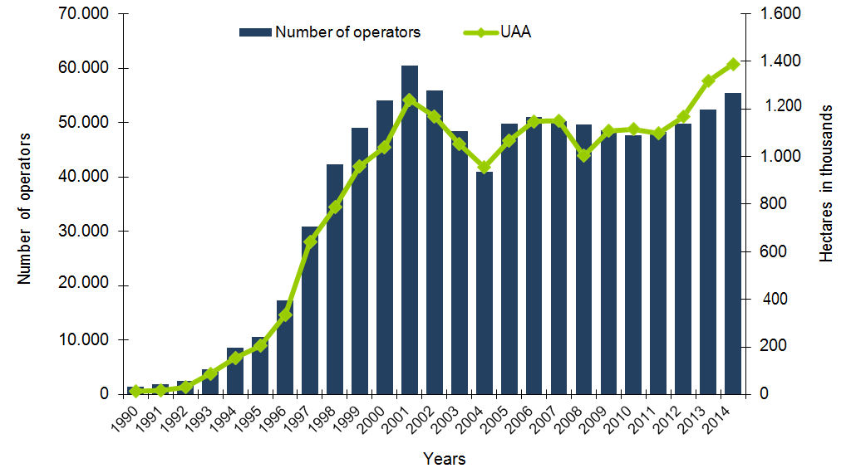

The Italian Regions with the largest number of organic operators were, at the end of 2014, Sicily (9,660), Calabria (8,787) and Apulia (6,599). These regions accounted for more than 45% of the total Italian organic operators.
The largest extension of organic surfaces was also located in these three regions, respectively with 303,066 hectares in Sicily, 176,998 hectares in Apulia and 160,164 hectares in Calabria. The organic surface of these three regions accounted for 46% of the national organic surface.
The regions with a higher percentage of organic farmland on total cultivated surfaces were: Calabria, where the organic surfaces accounted for about 30% of the total areas; followed by Sicily, with 22%, and Lazio, with 19%.

 | Producers esxclusive | Producers / Processors | Processors exclusive | Importers | Total  31/12/2013 | Total operators 31/12/2014 | Var. % '14 - '13
TOTAL | 42.546 | 6.104 | 6.524 | 259 | 52.383 | 55.433 | 5,8
SICILIA | 8.492 | 531 | 625 | 12 | 9.888 | 9.660 | -2,3
CALABRIA | 7.860 | 680 | 243 | 4 | 7.168 | 8.787 | 22,6
PUGLIA | 4.803 | 1.223 | 563 | 10 | 6.254 | 6.599 | 5,5
TOSCANA | 2.621 | 1.063 | 472 | - | 3.701 | 4.156 | 12,3
EMILIA ROMAGNA | 2.678 | 327 | 816 | 55 | 3.718 | 3.876 | 4,2
LAZIO | 2.607 | 269 | 363 | 8 | 3.220 | 3.247 | 0,8
SARDEGNA | 2.233 | 100 | 74 | - | 2.228 | 2.407 | 8,0
MARCHE | 1.707 | 263 | 211 | 6 | 2.162 | 2.187 | 1,2
PIEMONTE | 1.361 | 294 | 424 | 41 | 1.998 | 2.120 | 6,1
CAMPANIA | 1.474 | 190 | 343 | 9 | 1.923 | 2.016 | 4,8
VENETO | 942 | 276 | 619 | 43 | 1.804 | 1.880 | 4,2
LOMBARDIA | 725 | 243 | 697 | 35 | 1.725 | 1.700 | -1,4
ABRUZZO | 1.074 | 179 | 204 | 4 | 1.448 | 1.461 | 0,9
BASILICATA | 1.047 | 96 | 81 | 1 | 1.166 | 1.225 | 5,1
UMBRIA | 891 | 183 | 137 | 6 | 1.203 | 1.217 | 1,2
PA BOLZANO | 830 | 8 | 247 | 7 | 1.644 | 1.092 | 6,1
PA TRENTO | 534 | - | 116 | 2 |  | 652
FRIULI VENEZIA GIULIA | 220 | 87 | 128 | 6 | 417 | 441 | 5,8
LIGURIA | 207 | 59 | 113 | 10 | 385 | 389 | 1,0
MOLISE | 165 | 24 | 41 | - | 238 | 230 | -3,4
VALLE D’AOSTA | 75 | 9 | 7 | - | 93 | 91 | -2,2

In 2014, the main organic productions in Italy were fodder, pastures and cereals, followed by surfaces under olive growing. Even for livestock production, distinguished on the basis of the main farmed species, the data show a substantial increase on 2013, in particular for pigs (+ 15.2%) and poultry (+ 13.9%); slight drop only for cattle and horses. The performance of holdings engaged in organic aquaculture sector also was quite good: in 2014 they grew up to 41. The regional breakdown of organic aquaculture holdings saw a greater concentration in Veneto and Emilia Romagna.
According to the Italian Institute of Services for the Agricultural and Food Market (ISMEA) estimates, the domestic market (off-trade) of organic products in Italy showed a value of more than 2.1 billion euros. The estimate does not include the turnover linked to the on-trade channel, related to sales undertaken by catering, bars and food services. Modern Distribution (hypermarkets, supermarkets, discount stores) and specialized stores, including small, medium and large surfaces, moved a total of more than 75% of the turnover of this segment. Always according to Ismea estimates, Modern Trade, in particular, presented a retail sales value of over 855 million euro, with about 40% share. Specialized store sales reached a volume of about 761 million euro, equivalent to 35.5% of the entire value of the organic retail market. The remaining channels are accredited by ISMEA estimates of an overall incidence of almost 25%, represented for 10% by small farmer markets, direct sales, purchasing groups and e-commerce, for 8.9% by traditional shops and for 5.1% from pharmacies. An almost negligible 0.6% was the overall share of health food stores and drugstores.

Traditional shops
8,9%
Pharmacies
5,1%
Healt food Stores and drugstores
0,6%
Small farmer markets, direct sales, purchasing groups, e- commerce
10,0%
Large scale retail
39,9%
€

2.145.188.414
Medium-small
specialized 20,8%
Large specialized
14,7%

RESEARCH

Organic farming is the main driver of agro-ecological research in Italy.
Besides the incentives that the Rural Development Programmes provide for the research, an Italian Finance Act edited in 2000 (L. 12/23/1999 no. 488) established a fund for research on organic and quality agriculture. The fund was aimed at financing every year national and regional research programs in the field of organic farming, as well as on the theme of safety and healthiness of food. The fund, fed by a 2% contribution based on the previous year's turnover of companies’ sales of pesticides and synthetic fertilizers, is managed by the Italian Ministry of Agriculture. It finances a number of research activities among which the European program CORE Organic (Coordination of European Transnational Research in Organic Food and Farming Systems). It is part of the ERA-NET activities, which are coordinating and supporting activities part of the EU Research Framework Programme (http://www.coreorganic.org/). The Sinab (Italian Information System on Organic Agriculture) regularly reports on the research and experimentation projects launched as part of this fund (www.sinab.it).
In September 2015 the International Conference “Agroecology for Organic Agriculture in the Mediterranean” was held in Vignola (Modena), with the objective to improve interdisciplinary scientific dialogue, information exchange and dissemination of knowledge and innovation in the field of “Mediterranean Agroecology and organic agriculture. Mainstreaming agro-ecological research and organic farming innovation”. The conference, celebrating its 25th edition , was organized by IFOAM AgriBioMediterraneo, established in Vignola in 1990 as a regional department of the “International Federation of Organic Agricultural Movement (IFOAM).
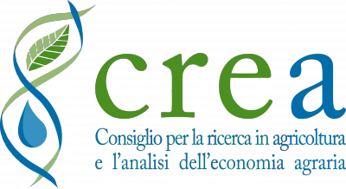
CREA – The Council for Agricultural Research and Analysis of Agricultural Economics. Consists of 12 Centers, of which 6 related to specific areas and 6 related to the supply chain. "Research for organic and biodynamic farming: an overview" was the title of the workshop organized in January 2016 by CREA, which saw the participation of most of the Italian institutions and researchers involved in the sector. During the meeting the Deputy Minister of Agriculture, Food and Forestry announced the launch of the National Strategic Plan for the development of the Italian organic farming system, which foresees the drafting of a national plan for research and innovation in organic farming and the establishment of a standing committee for the overall coordination of research in organic and biodynamic farming, with the involvement of institutions supervised by the Italian Ministry of Agriculture. Contacts: www.crea.gov.it. Via Po, 14 – 00198 Rome.
Other Organizations involved in the research activities in Agro-ecology and organic farming in Italy are: INROF, PTBio Italia, FROBA.
INROF - Italian Network for the Research in Organic Farming (in Italian: “RIRAB – Rete Italiana per la Ricerca in Agricoltura Biologica”). In November 2010, INROF/RIRAB adopted a new organizational structure, intending to strengthen its commitment towards scientific research advancement in the field of organic food and farming in Italy. The Italian Network for the Research in Organic Farming is now organized into nine Thematic Working Groups with more than 300 members. The 2nd INROF Congress took place in Rome in June 2014 and was structured in 3 sessions: agro-ecology, sustainable organic food chains, biodiversity. Contacts: www.rirab.it – Headquarters at CNR (The National Research Council) Agribusiness Department, Piazzale Aldo Moro,7 - 00185 – Rome.
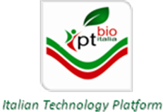
PTBio Italia - Italian Technology Platform on Organic Food and Farming. In March 2010 a discussion Forum promoted by INROF - Italian Network for the Research in Organic Farming - was activated and a decision to actively participate in building an Italian Technology Platform on Organic Food and Farming was taken. At the end of an intensive preparatory work, PTBio Italia has been officially presented to Italian policy makers (Representatives of the Ministry of the Agriculture Policy and Ministry of the Environment) and more recently a website (www.ptbioitalia.it) has been established.
FROBA - Italian Foundation for Research in Organic and Biodynamic Agriculture (in Italian: “FIRAB – Fondazione Italiana per la Ricerca in Agricoltura Biologica e Biodinamica”) was founded to progress in the knowledge area on, for, from and with organic farmers. The Foundation’s rationale was in fact aimed to: the promotion of information on the multiple roles organic farming plays in sustainable development; the dissemination of research results thus increasing organic farmers’ ability to cope with technical and economic problems; the sharing of on-farm experiences and best practices; the creation of an enabling environment for research partnership. FIRAB has thus the ambition to translate into concrete operative options the cooperative research approach, facilitating the exchange of information and expertise among organic farmers and scientists.
FROBA was initiated in 2007 following a proposition launched by AIAB (Italian Association for Organic Farming) and the Italian Biodynamic Association, soon endorsed by other social organizations, who later became co-founders: Legambiente (the main national environmental organization) and UILA (one of the most representative agroindustry workers union).
FIRAB is an unique Italian not-for-profit entity with a specific focus on research in organic and biodynamic farming.
FIRAB vision is to investigate on a sustainable development model for agriculture, taking as a basis organic and biodynamic agriculture for its positive impact on production activities, environment conservation, quality of food and therefore of people wellbeing. Contacts: www.firab.it. Via Pio Molajoni, 76 - 00159 Rome.

TRAINING / PEDAGOGY
The educational and training offer in agro-ecology and organic farming in Italy is very high and distributed to all levels of education, from primary schools (with awareness programs included in POF), in the secondary ones (in particular those that propose agricultural studies), up to university careers and the Masters of Science in Agroecology.
We report below some of the most interesting courses of study.
The University Sant’Anna of Pisa promotes a course on “applied agroecology” targeted to undergraduate and post-graduate, an international PhD Programme in Agrobiodiversity and research activities on the Management of functional biodiversity at species and habitat level for the provision of agroecosystem services; agroecological management in low external input (LEI) and organic cropping and farming systems; integrated pest and weed management. Professor Paolo Bàrberi, head of the Agroecology research area of the Institute of Life Sciences of the University Sant’Anna, participated in January 2016 at the creation of Agroecology Europe, a European association to promote Agroecology, with the participation of 19 founders from 10 countries. Agroecology Europe intends to place Agroecology high on the European agenda of sustainable development of farming and food systems. It wants to foster interactions between actors in sciences, practices and social movements, by facilitating knowledge sharing and action. It aims at the creation of an inclusive European community of professionals, practitioners, and more generally societal stakeholders in agroecology.
The working Group “Sustainable Agriculture and land management” is part of the Department of Agrifood Production and Environmental Sciences, University of Florence (UNIFI-DISPAA). It offers courses for a number of programs at the School of Agriculture of the University of Florence and other public and private bodies in Italy, including the Mediterranean Agronomic Institute of Bari (MAIB), part of the International Centre for Advanced Mediterranean Agronomic Studies (CIHEAM) and the University of Gastronomic Sciences at Bra, Italy. Course topics range from agroecology, sustainable management of agroecosystems, indicator-based methods for integrated sustainability impact assessment, eco-management auditing. Current research interests include sustainable agriculture and land management, integrated ecological-economic modelling and evaluation of farming systems, organic agriculture, agri-environmental indicators, eco-management auditing, participatory frameworks for assessment of natural resource management projects.
The international Master of Science in Agroecology is 2 years long, corresponding to 120 credits (ECTS). Originated by the collaboration between the University of Tuscia and the University of Turin, which, together with NOVA (association of seven Scandinavian Universities) and FESIA (a French association of five Agricultural Schools for Agricultural Engineering and Agricultural Productions), designed the programme in order to best integrate the skills of the different universities in the field of Agroecology. As a second level study programme (MSc), it completes logically and consistently the Bachelor’s Degrees in Ecological Agriculture, Organic Production and Farming, Protection of Horticultural Crops, Agricultural Science and Technology.
This interesting and new international didactic programme was approved and financed by the Italian Ministry for Education, University and Research within the Internationalization plan for increasing of the university system. Currently, however, it is active in Norway (through NOVA) and France (through ISARA Lyon).
The Mediterranean Agronomic Institute of Bari (MAIB), part of the International Centre for Advanced Mediterranean Agronomic Studies (CIHEAM) promotes the MOA – Mediterranean Organic Agriculture Master programme that aims at preparing graduates to produce innovation in Mediterranean organic agriculture, creating and maintaining sustainability in the farming system, assisting and contributing to national development of organic legislations and regulatory framework.
Among the pedagogical initiatives we can highlight the agro-ecological food garden promoted by Slow Food, during Expo 2015 in Milan. A laboratory that gave visitors plenty of inspiration to create their own food gardens, to raise beds or in pots on a balcony. The initiative, which was very successful during Expo 2015, keeps expanding thanks to the association Slow Food. The garden is a site for on-going education. Wandering past the beds, you can pick up essential tips on how to create a garden using an agro-ecological approach, while discovering the functions of different plants, understanding the best techniques for planning and cultivation, seeing how flowers can help protect crops from harmful insects and learning how to naturally enrich the soil.

CONCLUSIONS

From the encounter of the modern agro-ecology (that involves various approaches and dimensions, such as the environmental, the economic, the ethical and the social ones) with the Organic 3.0 (bringing organic out of its current niche), arises a new model, open, inclusive and comprehensive, able to support the ecological transition of the farms and of the territories.
However, it should be noted that Agro-ecology and organic agriculture, as scientific disciplines, as approaches to sustainable farming practice, as social movements – have objectives similar, which, however, often they reach differently.
In Italy the organic sector shows concrete agro-ecological solutions for agriculture and food systems.
In Italy there are 21 RDPs approved by EU, for a total amount of 1.689 millions of euro of public support for the organic farming sector, in transition from Organic 2.0 to Organic 3.0.
The Italian Ministry of Agriculture, in 2016, introduced the agro-ecological approach in the National Action Plan for organic farming.
The Italian experience of the bio-district/Eco-region responds perfectly to this new model, and combines in the best way agro-ecology and organic farming.
An analytical framework for the classification and performance monitoring of the Bio-districts/Eco-regions, was carried out by Professor Cesare Zanasi of Bologna University. The framework integrates four different approaches: an adaptation of the Porters’ Diamond analysis of the Industrial Clusters competitiveness; an evaluation scheme for measuring the degree of compliance of the Bio-districts/Eco-Regions with their principles; a classification scheme of the Clusters’ stage of development and a classification scheme for defining the Bio-districts/Eco-Regions’ market orientation typologies.
Organic farming is the main driver of agro-ecological research in Italy.
The educational and training offer in agro-ecology and organic farming in Italy is very high and distributed to all levels of education.
In Italy even environmental associations are engaged in the dissemination of agro-ecology principles. Legambiente has been always committed to promote a new paradigm of eco-quality agriculture in order to avoid the excessive exploitation of natural resources, soil, water and air: a new agriculture aiming at producing healthy GMO-free and safe food in total respect of the Environment. Agriculture must also play a key role to reduce soil exploitation, mitigate climate change effects, contribute to revive the economy of the country and develop a green economy creating new jobs.
In 2015, on the event of the International Expo of Milan, entitled “Feeding the planet, energy for life”, the historical awareness campaign of Legambiente “Green Train” has been focused on agriculture and food. That was a great opportunity to introduce the “New Agriculture Manifesto” and the new agriculture project involving farmers, scientists, agriculture and environment ministries and departments of all regions.
Such instrument aims at increasing biological production in Italy in the next years and enlarging the “bio” agricultural areas from the actual 11% to 20% within 2020.

BIBLIOGRAPHY

- Holy Father Francis (2015), Laudato si’, Encyclical Letter on care for our common home. Città del Vaticano, Vatican Press. ISBN 978-88-209-9580-5.
- Monteduro Massimo, Buongiorno Pierangelo, Di Benedetto Saverio, Isoni Alessandro (2015), Law and Agroecology. A transdisciplinary dialogue. Heidelberg, Springer. ISBN 978-3-662-46616-2.
- Ferrante Andrea, Korzenszky Anna, Lange Jeannette, Maass Henrik (2015), The meaning of Agroecology from a European peasant perspective. Future of food: journal on food, agriculture and society, 2-winter 2014/2015.
- Caporali Fabio (2007). Agroecology as a science of integration for sustainability in agriculture. Ital. J. Agron., 2007, 2:73-82
- Caporali Fabio, Campiglia Enio, Mancinelli Roberto (2010). Agroecologia. Teoria e pratica degli agroecosistemi. Milano, Città Studi. ISBN 9788825173529.
- Caporali Fabio (2015), History and development of agroecology and theory of agroecosystems. In "Law and Agroecology", ( Monteduro, M., Buongiorno, P Di Benedetto, S e Isori, A. Eds.) , 3-29, Springer.
- Bàrberi Paolo (2012). Agroecology for sustainable agriculture. European Science and Technology 17, 63.
- Erba Valeria, Di Martino Mina, Agostini Stella (2010), Guida alla pianificazione territoriale sostenibile. Strumenti e tecniche di agroecologia. Santarcangelo di Romagna (RN), Maggioli Editore. ISBN 97888838754838.
- Desmarais Annette Aurélie (2009), La Vía Campesina. Milano, Jaca Book. ISBN 978-88-16-40877-7.
- Peasant Agroecology for food sovereignty and mother earth. Experiences of la Vía Campesina. Notebook 7, April 2015.
- Wezel A., Bellon S., Doré T., Francis C., Vallod D. & David C. (2009), Agroecology as a science, a movement and a practice., Agronomy for Sustainable Development Journal (www.agronomy-journal.org), Les Ulis (France), EDP Sciences.
- Willer, Helga and Julia Lernoud (Eds) (2016), The World of Organic Agriculture. Statistics and Emerging Trends 2016. Research Institute of Organic Agriculture (FiBL), Frick, and IFOAM – Organics International. ISBN FIBL printed version 978-3-03736-306-5.
- Moeskops Bram (Ed) (2014), The European Innovation Partnership – Opportunities for innovation an organic farming and agroecology, Brussels, IFOAM EU Group (http://www.ifoam-eu.org/sites/default/files/page/files/ifoameu_research_eip_dossier_en_201402.pdf).
- Hilbeck Angelika, Oehen Bernadette (EDs) (2015), Feeding the people – Agroecology for nourishing the World and transforming the Agri-food system, Brussels, IFOAM EU Group (http://www.ifoam-eu.org/sites/default/files/ifoameu_policy_ffe_feedingthepeople.pdf).
- Urs Niggli (2015), Incorporating agroecology into organic research – an ongoing challenge, Sustainable Agriculture Research vol. 4 No. 3 2015, Published by Canadian Center of Science and Education. http://orgprints.org/29200/.
- Markus Arbenz, David Gould, Christopher Stopes (2015) Discussion Paper Organic 3.0 for truly sustainable farming & consumption, based on think tanking by SOAAN & IFOAM Organics International, launched at the International Organic Expo 2015, Goesan County.
http://www.ifoam.bio/sites/default/files/organic3.0_web.pdf.

Fabio Caporali (2015), Pietro Cuppari precursore dell’agroecologia e del governo sostenibile del territorio, ETS editore
Girolamo Azzi (1928), Ecologia agraria, Unione tipografico-editrice torinese
Alfonso Draghetti (1948), Principi di fisiologia dell’azienda agraria, Bologna, Istituto editoriale agricolo
Fabio Caporali (2015), History and development of agroecology and theory of agroecosystems. In “Law and Agroecology” (Monteduro M., Buongiorno P., Di Benedetto S., Isori A. Eds.), 3-29, Springer
Fabio Caporali (2010), Agroecology as a transdisciplinary science for a sustainable agriculture. In "Biodiversity, Biofuels, Agroforestry and Conservation Agriculture" (Lichtfouse, E , Ed.), 1-71. Springer.
Holy Father Francis (2015), Laudato si’, Encyclical Letter on care for our common home (http://w2.vatican.va)
Bio in cifre 2015, published in February 2016, SINAB – Italian Information System for Organic Farming (http://www.sinab.it)
Cesare Zanasi, Annarita Antonelli, Salvatore Basile, Patrizia Pugliese, Cosimo Rota (2015), Eco-Regions: an innovative solution for the integrated sustainable development of rural areas. Global Bioeconomy Summit 2015, Berlin. http://gbs2015.com/fileadmin/gbs2015/Downloads/Proceedings_neu_2.pdf - pag. 66.

